**Chapter 1**

**INTRODUCTION**

A database is a collection of related data, typically stored on disk, and accessible by possibly many concurrent users. Databases are generally separated into application areas. For example, databases may contain Human Resource data, sales data, accounting data.

A database has the following implicit properties:

1. A database represents some aspect of the real world, sometimes called the mini world or the Universe of Discourse. Changes in the real world will be reflected in the database.
2. A database is a logically coherent collection of data with some inherent meaning. A random assortment of data cannot be referred to as a database.
3. A database is designed, built, and populated with data for a specific purpose. It has an intended group of users and some predefined applications in which these users are interested.

Databases are managed by a Database Management System.

* 1. **Database Management System**

A Database Management System (DBMS) is a set of programs that enables users to create and maintain a database. The DBMS is a general-purpose software system that simplifies the processes of defining, constructing, manipulating, and sharing databases among various users and applications.

Defining a database involves specifying the data types, structures and constraints of the data to be stored in the database. The database definition or descriptive information is also stored in the database in the form of a database catalog or dictionary; it is called meta-data. Constructing the Database is the process of storing data on some storage medium that is controlled by DBMS. Manipulating a database includes functions such as querying the database to retrieve specific data, updating the database to reflect changes in the mini world, and generating the report from the data. Sharing a database allows multiple users and programs to access the database simultaneously.

An Application Program accesses the database by sending queries or requests for data to the DBMS. A query typically causes some data to be retrieved.

* 1. **Project Description**

Online Food Ordering And Portal Management System is a web portal, useful for buying food items online. It facilitates to access the item information of a particular item in a catalog. This system will also help in reducing the manual work of buying the food items from hotels or restaurants, and automates the process. The customer can buy the required food items in just a single call .

System presents an interactive and up-to-date menu with all available options in an easy to use manner. Customer can choose one or more items to place an order. Once the order is placed it is entered in the database and retrieved in pretty much real time. Then employees can process all orders efficiently and effectively with minimal delays and confusion.

* 1. **Introduction to SQL**

Structured Query Language (SQL) is a programming language used for storing and managing data in Relational DBMS (RDBMS). SQL was the first commercial language introduced for E.F Codd's Relational model. Today almost all RDBMS (MySql, Oracle, Infomix, Sybase, MS Access) uses SQL as the standard database language. SQL is used to perform all type of data operations in RDBMS.

**SQL Command**

SQL defines following data languages to manipulate data of RDBMS.

**DDL : Data Definition Language**

All DDL commands are auto-committed. That means it saves all the changes permanently in the database.

**Command Description**

**create** to create new table or database

**alter** for alteration

**truncate** delete data from table

**drop** to drop a table

**rename** to rename a table

**DML : Data Manipulation Language**

DML commands are not auto-committed. It means changes are not permanent to database, they can be rolled back.

**Command Description**

**insert**  to insert a new row

**update** to update existing row

**delete** to delete a row

**merge** merging two rows or two tables

**TCL : Transaction Control Language**

These commands are to keep a check on other commands and their affect on the database. These commands can annul changes made by other commands by rolling back to original state. It can also make changes permanent.

**Command Description**

**commit** to permanently save

**rollback** to undo change

**savepoint** to save temporarily

**DCL : Data Control Language**

Data control language provides command to grant and take back authority.

**Command Description**

**grant**  grant permission of right

**revoke** take back permission

**DQL : Data Query Language**

**Command Description**

**select** retrieve records from one or more table

* 1. **Applications of Database Management System**

Some of the fields where Database Management System is used are:

* Telecom: It has a database which keeps track of the information regarding calls made, network usage, customer details etc. Without the database systems it is hard to maintain that huge amount of data that keeps updating every millisecond.
* Industry: It has a manufacturing unit, warehouse or distribution center, each one needs a database to keep the records of ins and outs. For example distribution center should keep a track of the product units that supplied into the center as well as the products that got delivered out from the distribution center on each day; this is where DBMS comes into picture.
* Banking system: For storing customer info, tracking day to day credit and debit transactions, generating bank statements etc. All this work has been done with the help of Database management systems.
* Education sector: Database systems are frequently used in schools and colleges to store and retrieve the data regarding student details, staff details, course details, exam details, payroll data, attendance details, fees details etc. There is a lot of inter-related data that needs to be stored and retrieved in an efficient manner.
* Online shopping: Online shopping websites such as Amazon, Flipkart etc., stores product information, customer’s addresses and preferences, credit details and provide customers with the relevant list of products based on their query. All this involves a Database management system.

**Chapter 2**

**RESOURCE REQUIREMENTS**

* 1. **Hardware Requirements**

**T**he Hardware requirements are very minimal and the program can be run on most of the machines.

Processor : Intel® Core™ i3-2365M CPU @ 1.40GHz × 4

RAM : 4095MB RAM

Monitor Resolution : 1920 * 1080px

* 1. **Software Requirements**

Operating Syatem : Linux Ubuntu

Backend : MySQL

Frontend : Ruby on Rails, Bootstrap, HTML, CSS

HTML is an abbreviation of "HyperText Mark-up Language" - which is already more than you need to know at this stage. However, for the sake of good order, let us explain in greater detail.

Hyper is the opposite of linear. In the good old days - when a mouse was something the cat chased - computer programs ran linearly: when the program had executed one action it went to the next line and after that, the next line and so on. But HTML is different - you can go wherever you want and whenever you want. For example, it is not necessary to visit MSN.com before you visit HTML.net.

First developed by [Tim Berners-Lee](https://www.computerhope.com/people/tim_berners-lee.htm)in [1990](https://www.computerhope.com/history/1990.htm), HTML is short for HyperText Markup Language. HTML is used to create electronic documents (called pages) that are displayed on the World Wide Web. Each page contains a series of connections to other pages called [hyperlinks](https://www.computerhope.com/jargon/h/hyperlin.htm). Every web page you see on the Internet is written using one version of HTML code or another. Text is self-explanatory.

CSS stands for Cascading Style Sheets. CSS describes how HTML elements are to be displayed on screen, paper, or in other media. CSS saves a lot of work. It can control the layout of multiple web pages all at once. External stylesheets are stored in CSS files build responsive, mobile-first projects on the web with the world's most popular front-end component library.

Bootstrap is an open source toolkit for developing with HTML, CSS, and JS. Quickly prototype your ideas or build your entire app with our Sass variables and mixins, responsive grid system, extensive prebuilt components, and powerful plugins built on jQuery. JavaScript, often abbreviated as JS, is a high-level, dynamic, weakly typed, prototype-based, multi-paradigm, and interpreted programming language.

MySQL is a fast, easy-to-use RDBMS being used for many small and big businesses. MySQL is developed, marketed and supported by MySQL AB, which is a Swedish company. MySQL is becoming so popular because of many good reasons MySQL is released under an open-source license. So you have nothing to pay to use it. MySQL is a very powerful program in its own right. It handles a large subset of the functionality of the most expensive and powerful database packages. MySQL uses a standard form of the well-known SQL data language. MySQL works on many operating systems and with many languages including PHP, PERL, C, C++, JAVA, etc. MySQL works very quickly and works well even with large data sets. MySQL is very friendly to PHP, the most appreciated language for web development.

Ruby on rails , or Rails, is a sever-side wb application framework written in Ruby under the MIT. Rails is a model-view-controller (MVC) framework, providing default structures of database, a web sevice and web pages.

**Chapter 3**

**DESIGN**

* 1. **E-R Model**

An Entity–Relationship model (ER model) describes inter-related things of interest in a specific domain of knowledge. An ER model is composed of entity types (which classify the things of interest) and specifies relationships that can exist between instances of those entity types.

ER diagram should have mainly three components namely, entity, attribute, relationship. The notations shown in Fig.3.1.1 can be used for drawing an ER diagram.

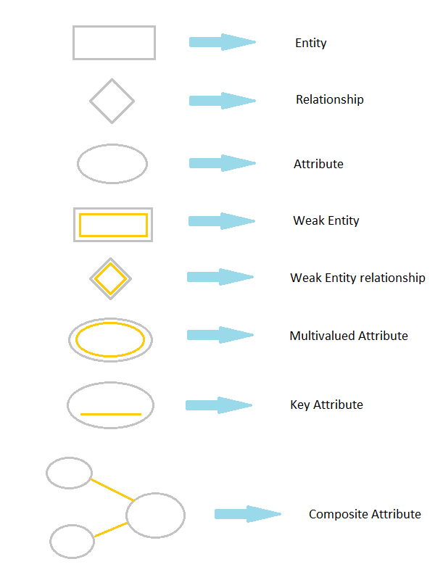

Fig. 3.1.1 E-R Diagram Notations

Fig. 3.1.2 shows the ER diagram for Online Food Ordering And Portal Management System. The E-R diagram shows the entities which are used to design

* Customers
* Catalogs
* Orders
* Shipments
* Payments

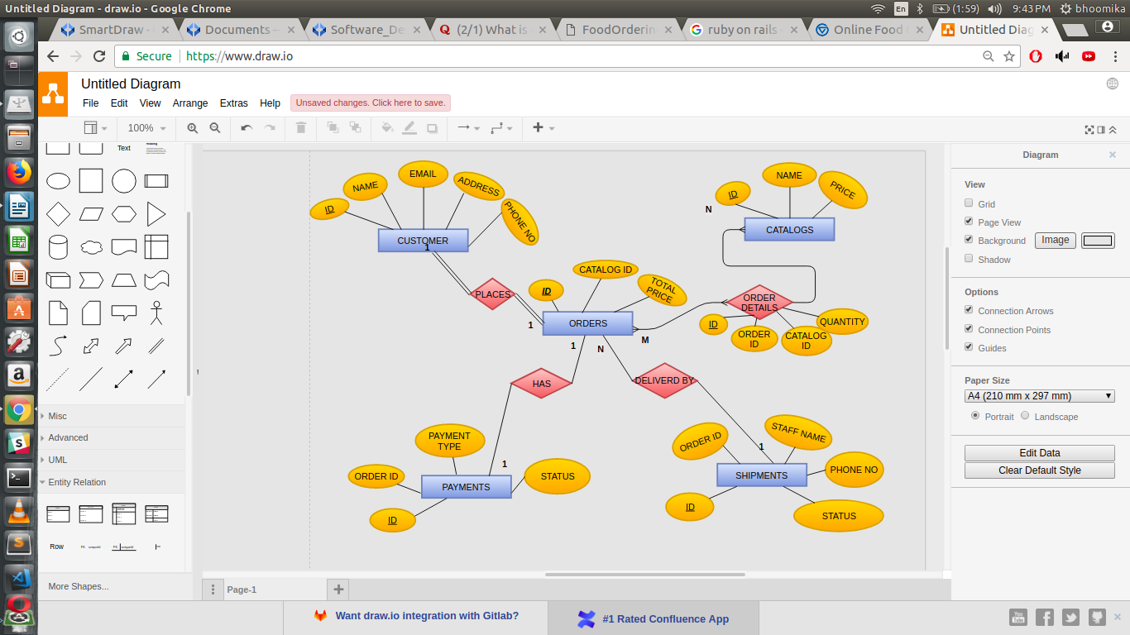

Fig. 3.1.2 E-R Diagram for Online Food Ordering And Portal Management System

* 1. **Relational Schema**

The relational schema diagram gives the relation of one entity with another as well as the information about the key constraints. Fig.3.2.1 shows the relational schema diagram of Online Food Ordering And Portal Management System in which the attributes that are underlined are the primary key and the arrow line is used to represent the mapping.

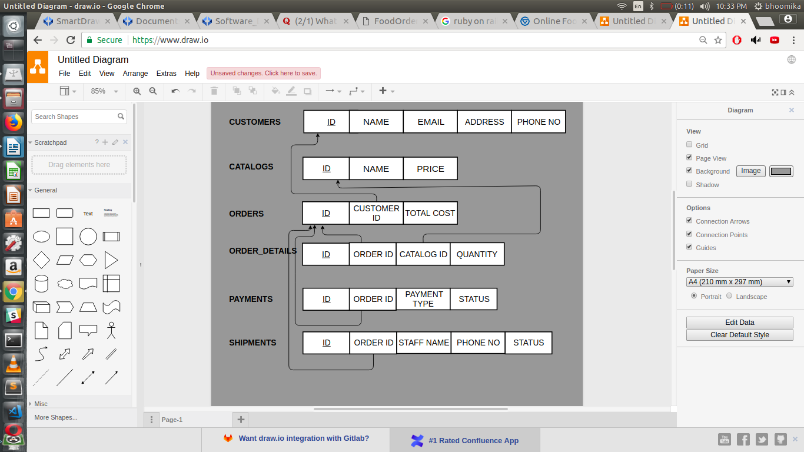

Fig. 3.2.1 S Online Food Ordering And Portal Management Schema Diagram

**Chapter 4**

**IMPLEMENTATION**

* 1. **Tables and their description**

Table 4.1.1 shows the list of tables used in implementation of Online Food Ordering And Portal Management System

Table 4.1.1 Tables used

sql> select * from tab;

|  |  |
| --- | --- |
| TNAME | TABTYPE |
| CUSTOMERS | TABLE |
| CATALOGS | TABLE |
| ORDERS | TABLE |
| ORDER_DETAILS | TABLE |
| PAYMENTS | TABLE |
| SHIPMENTS | TABLE |

Table 4.1.2 shows the description of CUSTOMERS table. This table is used to provide the customer details.

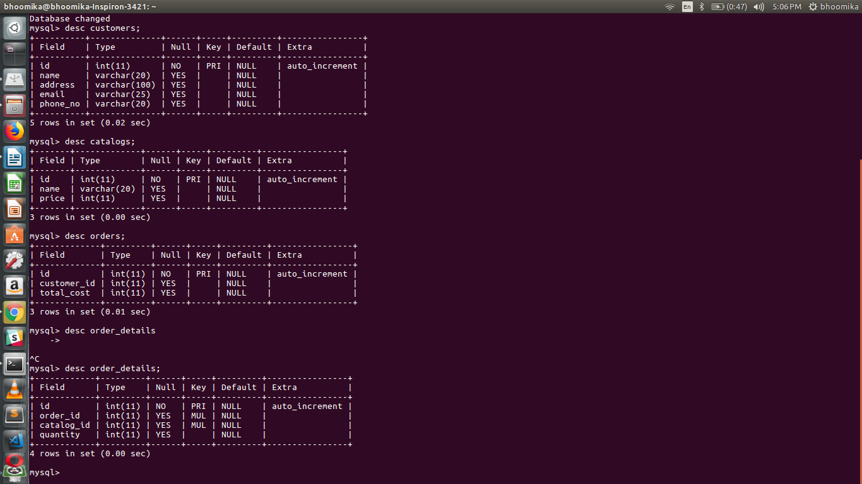Table 4.1.2 Customer Details

Table 4.1.3 shows the description of CATALOGS table. This table is used to provide the list of food items along with their prices.

Table 4.1.3 Catalogs Details

Table 4.1.4 shows the description of ORDERS table. This table is used to provide the details of the orders.

Table 4.1.4 Orders

Table 4.1.5 shows the description of ORDER_DETAILS table. This table is used to provide the quantity details of each item for any order.

Table 4.1.5 Order Details

Table 4.1.7 shows the description of PAYMENTS table. This table is used to provide information about the payments.

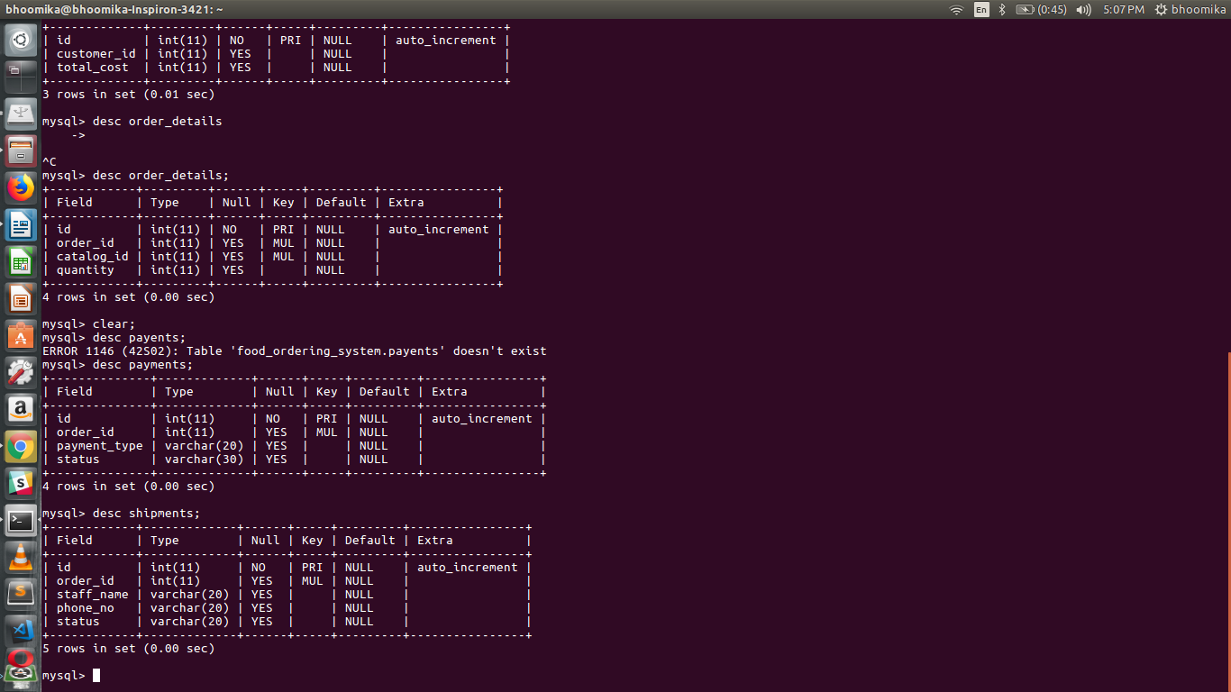Table 4.1.7 Payment Details

Table 4.1.6 shows the description of SHIPMENTS table. This table is used to provide the shipping details of an order.

Table 4.1.6 Shipment Details

**4.2 Code snippets**

**4.2.1 Insert code**

Fig 4.2.1 shows the code snippet of the insert operation. The server side language rails executes the sql insert query in order to add the row to the database.

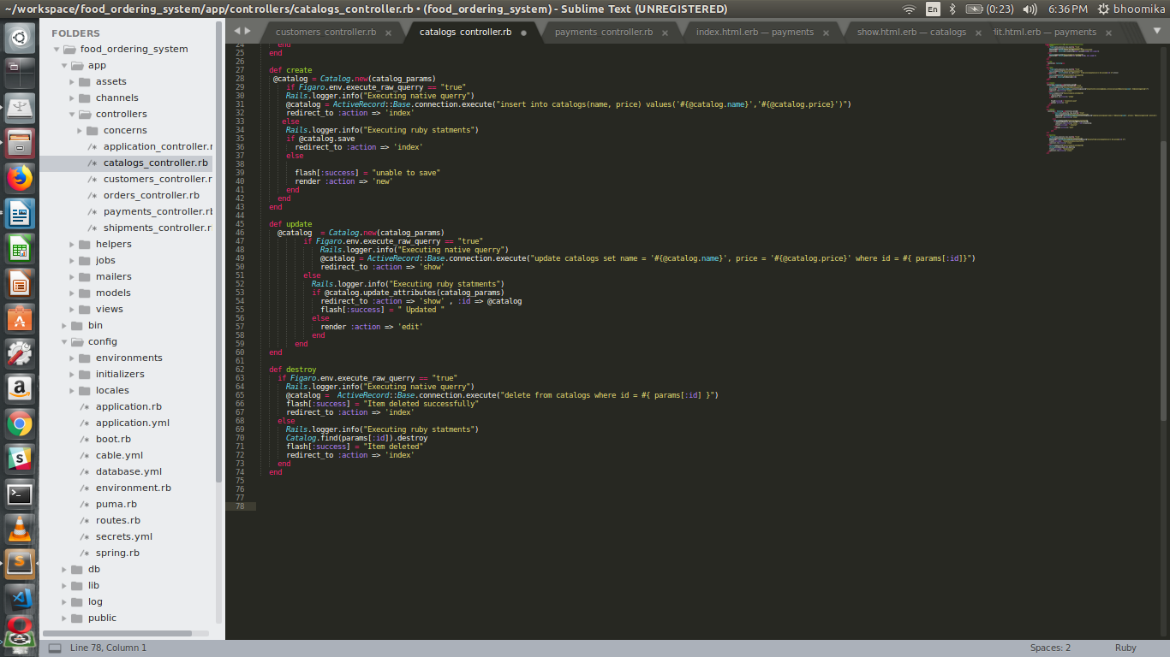Fig 4.2.3 Insert code

**4.2.2 Delete code**

Fig 4.2.2 shows the code snippet of the delete operation. The server side language rails executes the sql delete query in order to drop the row from the database.

Fig 4.2.3 Delete code

**4.2.3 Update code**

Fig 4.2.3 shows the code snippet of the update operation. The server side language rails executes the sql update query in order to update the values in the database.

Fig 4.2.3 Update code

**4.3 Trigger and Stored procedure code**

Fig. 4.3.1 shows the trigger which updates the value of quantity in the order_details table whenever the value of quantity is greater than 10 it sets the value to 10.

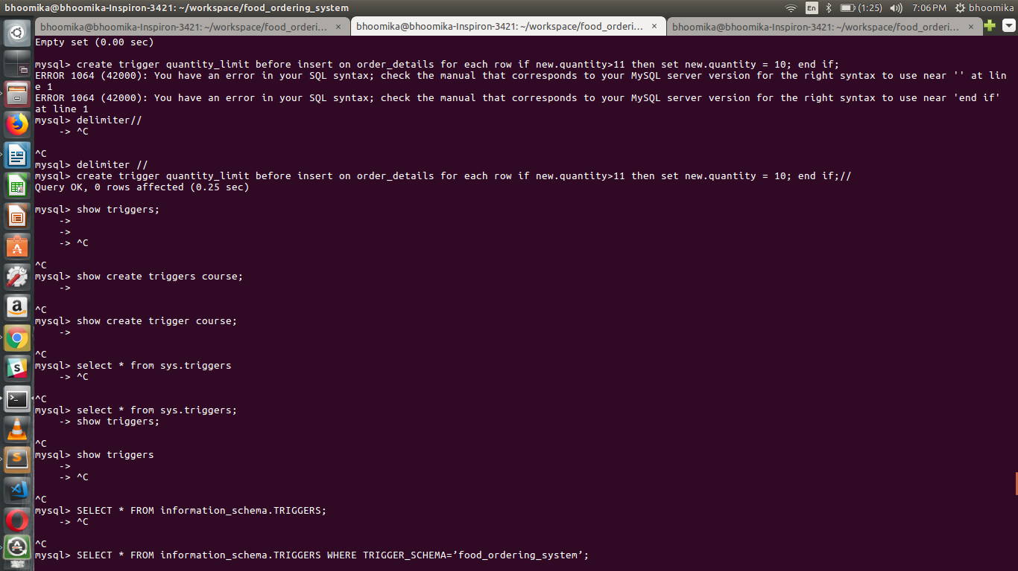 Fig. 4.3.1 Trigger

Fig. 4.3.2 shows the stored procedure which displays list of customers .

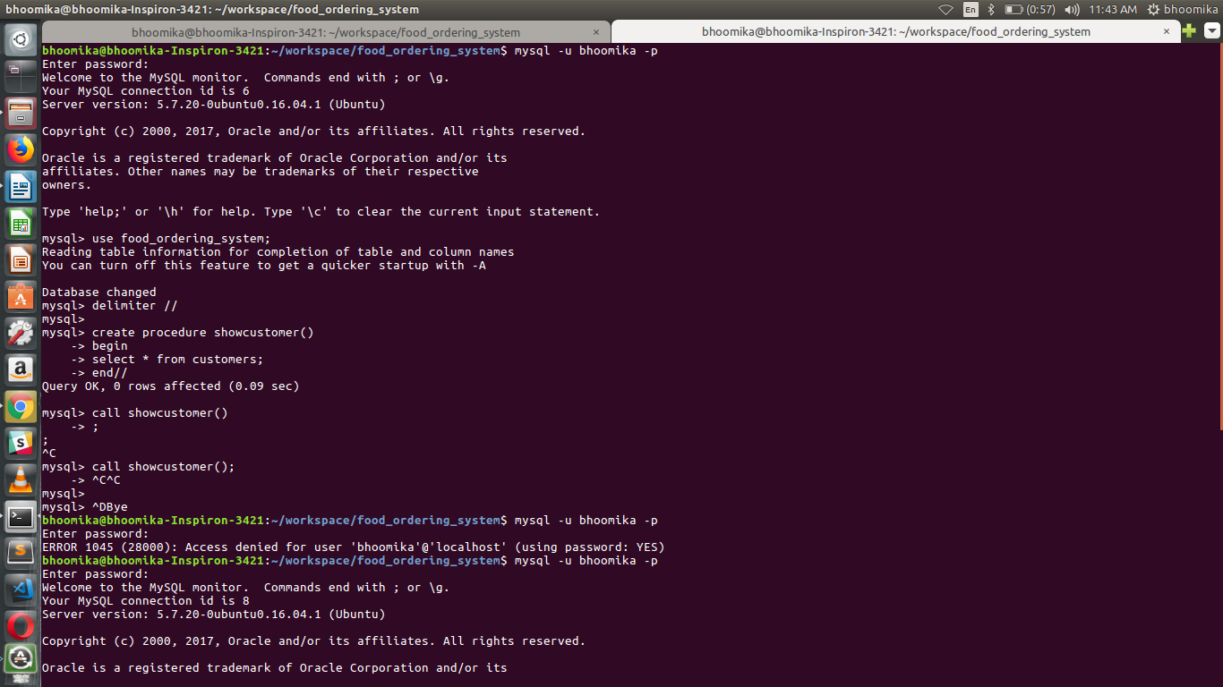Fig. 4.3.2 Stored procedure

**Chapter 5**

**RESULTS**

**Welcome page**

Fig. 5.1.1 shows the welcome page . It includes the navigation bar hence admin can 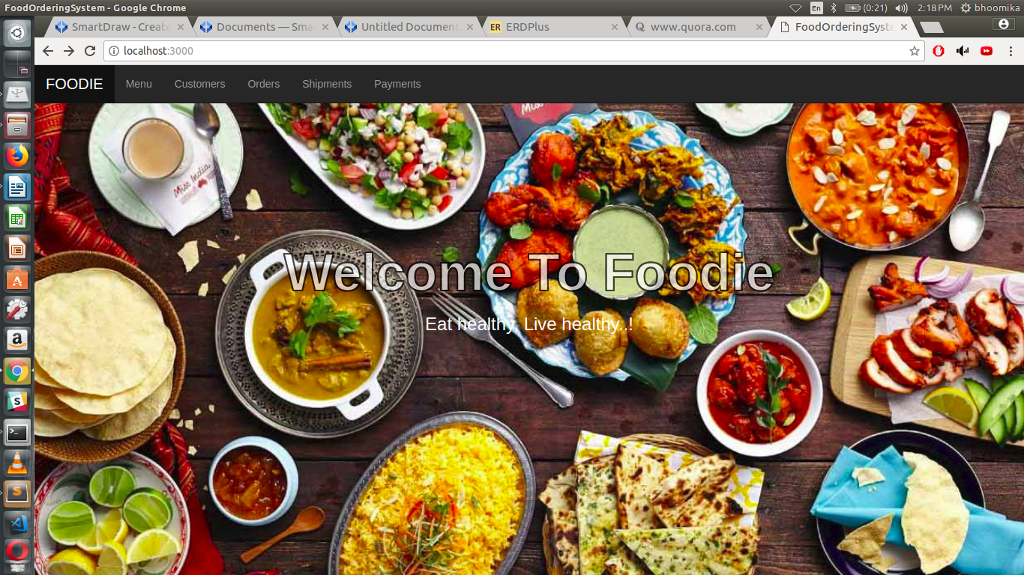navigate through any tab.

Fig. 5.1.1 Welcome Page

**Menu**

Fig. 5.1.2 shows the menu page . It has list of food items . Admin can add new items , update or delete items

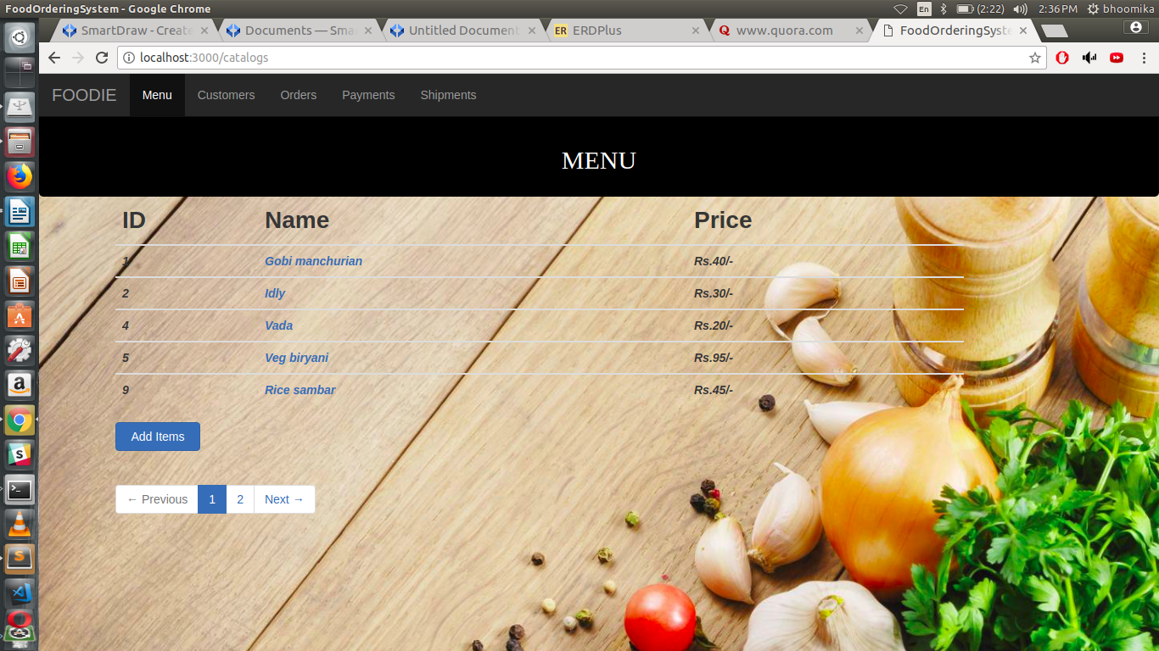 Fig. 5.1.2 Menu

**Order Page**

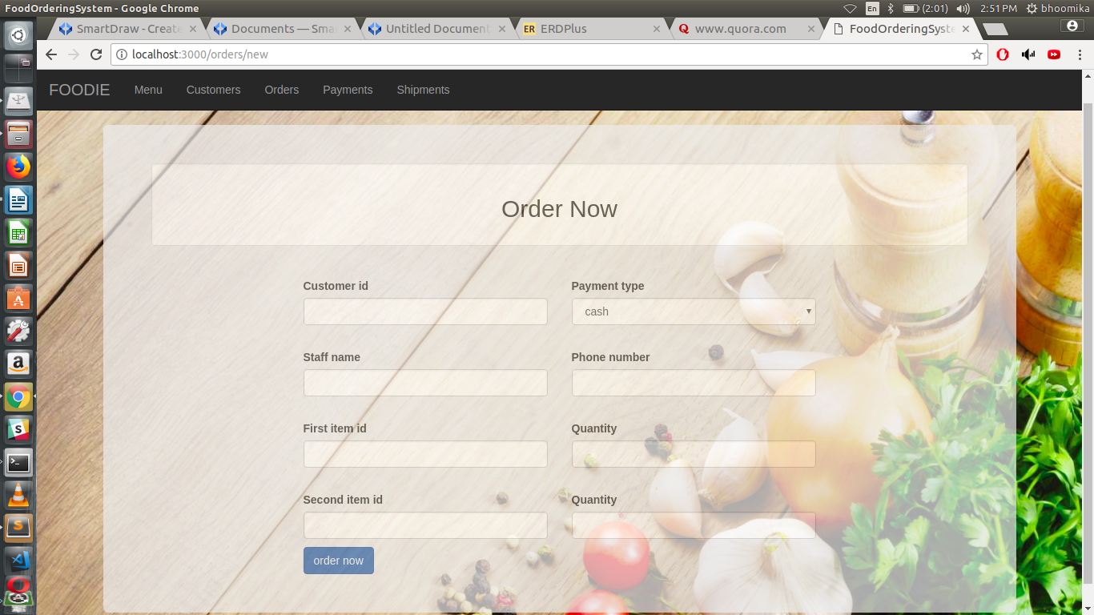Fig 5.1.3 shows the order page. Customer can order up to 2 items. And he/she can choose payment type.

Fig. 5.1.3 Order page

**Order Details**

Fig 5.1.4 shows the order details. It includes customer name, items and respective quantities, payment types and shipment details.

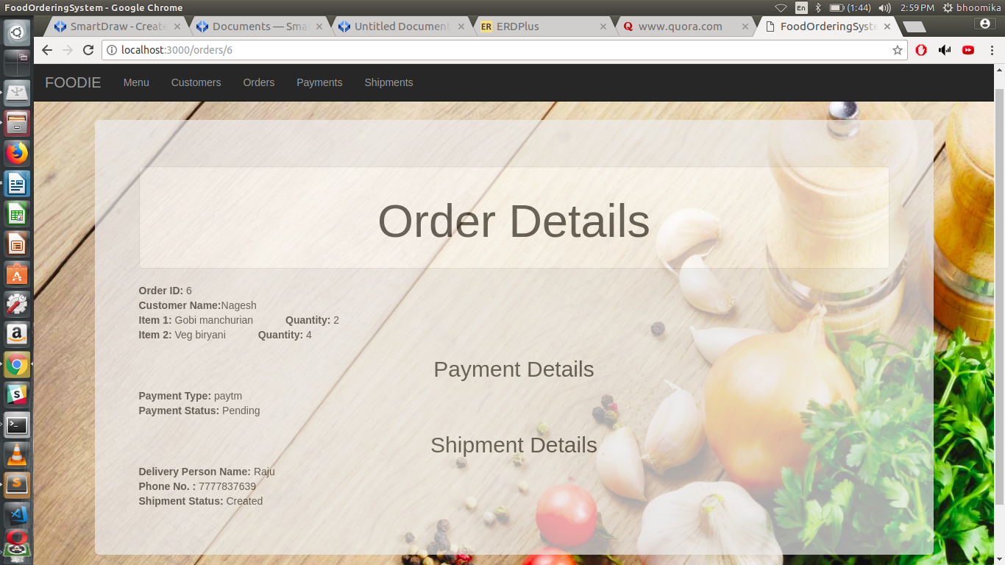 Fig. 5.1.4 Order Details

**Chapter 6**

**CONCLUSION AND FUTURE ENHANCEMENT**

* 1. **Conclusion**

Food portal management system is developed using Ruby on Rails. Project facilitates Admin to generate order details of any customer. The total cost of a particular order is generated. Admin can view about payment and shipment status. Also it allows easy and reliable data saving.

* 1. **Future Enhancement**

As the technology emerges, it is possible to upgrade the system and can be adaptable to desired environment. Based on the future security issues, security can be improved using encryption and decryption techniques. We can also provide administrative tools like backup. We can provide door-to-door delivery, returns if the customer is not satisfied, ratings on the food items for customers to evaluate the best item, discounts, wish lists, etc. The customer can also search the food item according to the price specified, discount percentage, etc. Customers can also provide customer reviews of the food items.

There are some limitations for the current system to which solutions can be provided as a **future development**:

1. The system is not configured for multi-users at this time. The concept of transaction can be used to achieve this.

2. The Website is not accessible to everyone. It can be deployed on a web server so that everybody who is connected to the Internet can use it.

3. Credit Card validation is not done. Third party proprietary software can be used for validation check.

As for other future developments, the following can be done:

1. The Administrator of the web site can be given more functionality, like looking at a specific customer’s profile, the books that have to be reordered, etc.

2. Multiple Shopping carts can be allowed.

**BIBLIOGRAPHY**

[1] Elmasri, Navathe, Fundamentals of Database Systems, Pearson Education, 5th Edition, 2006, ISBN- 978-81-317-1625-0.

[2] Raghu Ramakrishnan and Johannes Gehrke, Database Management Systems, Tata McGraw-Hill, 3rd Edition, 2003, ISBN- 0-07-123151-X.

[3] Silberschatz, Korth and Sudarshan, Database System Concepts, Tata McGraw-Hill, 5th Edition, 2002, ISBN- 007-124476-X.

[4] <https://www.w3schools.com/sql/>

[5] <https://www.w3schools.com/bootstrap/default.asp>

[6] <https://www.w3schools.com/css/default.asp>

[7] <https://www.railstutorial.org/book>